DL Lab 3 Solution

Digital Logic (Universiti Teknologi Malaysia)



School of Computing Faculty of Engineering UNIVERSITI TEKNOLOGI MALAYSIA

SUBJECT SESSION/SEM | :  : | SECR1013 DIGITAL LOGIC  …2…02…3…-2…0…24…/0…2…………………………………………….
LAB 3 | : | SYNCHRONOUS DIGITAL | COUNTER
NAME | : | ………………………………………………………………….
DATE | : | …11/06/2023

Lab #3

Identifying the Properties of a Synchronous Counter

Aims
  - Expose the student with experience on constructing synchronous counter circuit using Flip-Flop IC, Basic Gate ICs, Breadboard and ETS-5000 Digital Kit.
  - Promote critical thinking among students by analysing the given circuit and identifying the behaviour of the digital circuit.

Objectives
The objectives of this lab activity are to:
  - Implement a synchronous counter circuit into physical circuit using Breadboard, Flip-Flops, Basic Gates and Switches.
  - Completing the next-state table of the counter circuit.
  - Sketch the state diagram of the counter circuit.
  - Identify the properties of the counter.

Materials And Equipment

Materials and equipment required for this lab are as follows:

Item Name | Number of Item
1. Breadboard | 1
2. 7408 Quad 2-Input AND | 1
3. 7404 Hex Inverter | 1
4. 7432 Quad 2-input OR | 1
5. 7476 Dual J-K Flip Flop | 1
6. ETS-5000 Digital Kit | 1

Preliminary Works

  - Determine the logic level for each input combinations in Table 1 so that the desired result can be realized.

Table 1
Desired Result | PRE’ | CLR’ | J | K | CLK | Q
Set initial value Q = 1 | 0 | 1 | X | X | -- | 1
Output Q stays the same | 1 | 1 | 0 | 0 | ⇓ | 1
Output Q become 0, no change  in asynchronous input | 1 | 1 | 1 | 1 | ⇓ | 0
Output Q is not the previous Q | 1 | 1 | 1 | 1 | ⇓ | 1
RESET Q | 1 | 1 | 0 | 1 | ⇓ | 0
SET Q | 1 | 1 | 1 | 0 | ⇓ | 1

  - Answer all questions.

- Which state that JK flip-flop has, but not on SR flip-flop.

- Identify whether the JK flip flop in 7476, is a positive-edge triggered or negative- edge triggered flip flop.

Lab Activities (Design it using deeds software and complete)

- You are given a counter circuit as shown in Figure 4. the truth table

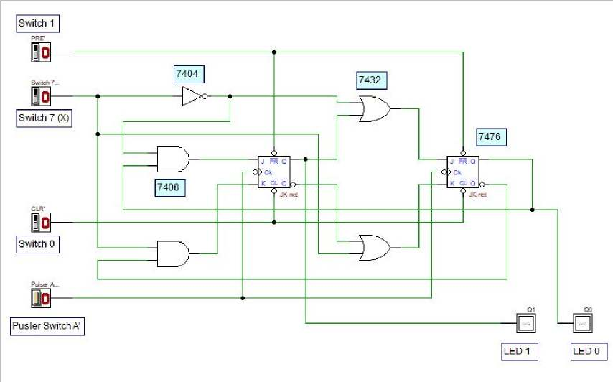

- Investigate the behaviour of the counter by observing the next state of the counter for all combination of Present State and X values. Complete the NextState table of the counter in Table 2. Ensure the Switch 0 is in HIGH state.
(0=LOW, 1=HIGH)

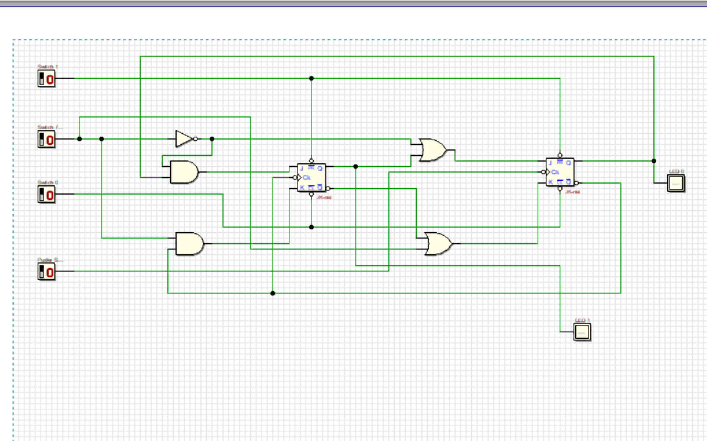

Table 2

Switch 7 | Present State |  | Next State
X | Q1 LED1 | Q0 LED 0 | Q1 LED1 | Q0 LED 0
0 | 0 | 0 | 0 | 0
0 | 0 | 1 | 0 | 1
0 | 1 | 0 | 1 | 0
0 | 1 | 1 | 1 | 1
1 | 0 | 0 | 0 | 1
1 | 0 | 1 | 1 | 0
1 | 1 | 0 | 0 | 0
1 | 1 | 1 | 1 | 1

